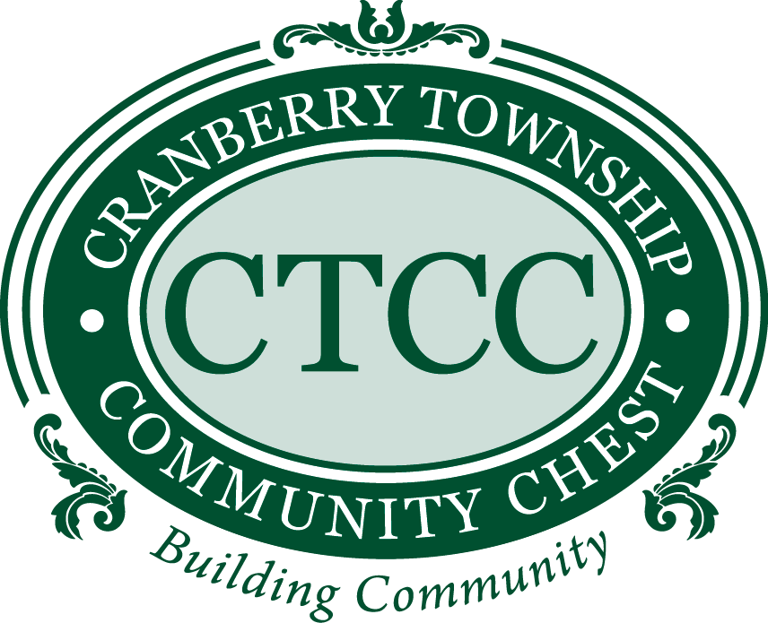

2525 Rochester Road, Ste. 450
Cranberry Township, PA 16066

APPLICATIONS FOR FUNDING: GUIDELINES FOR APPROVAL
The intention of the following guidelines is to outline the requirements for an Application for Funding to be approved. An Application for Funding can only be considered if the organization requesting funds follows the guidelines set below:
- The requester must be a current CTCC nonprofit organization or a civic organization and have been a member for longer than one year.
- The project or service that the organization is requesting funds for must be unique to that organization. Funds may not be requested for operational costs, license, or subscription fees.
- CTCC will provide a maximum of 50% of the project or service cost.
- The ideal project or service will create volunteering opportunities and/or value to our community. Please clearly explain how it will benefit our community.
- The project or service must be in the planning stages. Funds may not be requested for completed projects.
- CTCC reserves the right to refuse funding requests on duplicate or previously funded projects.
- CTCC will not fund individual Senior Projects. All requests tied to a Senior Project must be made by the member organization that will be benefitting from the Senior Project.
- Recipients of funding from the Cranberry Township Community Chest are required to submit a written declaration of the actual usage of the distributed funds within six (6) months of receipt of funds. This declaration must be signed by an officer of the organization.
- Your Application for Funding must be completed in its entirety and signed by an officer of the organization requesting funds. The Application for funding must be submitted via one of three ways:
  - Email to yourctcc@gmail.com
  - Mail via USPS to CTCC, 2525 Rochester Road, Ste. 450, Cranberry Twp., PA 16066
- CTCC will review the application at its next scheduled meeting and will reply back a few days after meeting. CTCC meets the third Wednesday of each month.
The following information must be completed, and the application signed by an officer of the organization requesting funding from CTCC. If the space provided is inadequate for your answer to any question, please complete the answer to such question on an 8 ½” x 11” piece of paper and attach it to this form. Also attach a summary of previous CTCC grants received by your organization.
1. Organization Name: ________________________________________________

2. Organization Address:________________________________________________
________________________________________________
3. Contact Person Information:

Contact Name:_________________________________________________

Contact Phone:_________________________________________________
Contact Email:__________________________________________________
4. Organization related questions:
  - Is your organization a recognized 501(c)(3) organization? __________
    - If so, what is your IRS Tax Identification Number? _________
    - If not, are you related in any way to a recognized 501(c)(3) organization?
___________________________________________________
  - Date incorporated or formed: _________________________________
  - Purposes for which your organization was formed and/or presently operates.
Please include a description of present and proposed future activities.
_____________________________________________________________
_____________________________________________________________
_____________________________________________________________
_____________________________________________________________

5. a. State the amount of money your organization is requesting, the purpose to which
such money will be applied, and the total amount of the project or service:
___________________________________________________________________
____________________________________________________________________
____________________________________________________________________
b. How will the remainder of the money be raised for this project?

_____________________________________________________________
_____________________________________________________________
_______________________________________________________________

c. Give a general timeline of the project from the time of receiving the grant to the
final completion date.
_______________________________________________________________

________________________________________________________________

________________________________________________________________

d. Additional comments that the CTCC Board should consider when reviewing your
grant application?

_________________________________________________________________

_________________________________________________________________

_________________________________________________________________

e. Explain how your project fits the CTCC guideline criteria.

_________________________________________________________________

_________________________________________________________________

_________________________________________________________________

Recipients of funding from the Cranberry Township Community Chest are required to submit a written declaration of the actual usage of the distributed funds within six (6) months of receipt of funds. This declaration must be signed by an officer of the organization. By signing below, agreement to this stipulation is understood and accepted.

DATE: _________________________________________________________

ORGANIZATION: _____________________________________________________

SIGNATURE & TITLE OF OFFICER: ___________________________________________________

PRINTED NAME AND TITLE: ________________________________________________________
Please submit the completed form by one of the following methods:
- e-mail it to yourctcc@gmail.com
- fax it to 724.776.5488 or
- mail it via USPS to CTCC, 2525 Rochester Road, Ste. 450, Cranberry Twp., PA 16066

For CTCC Use Only

Name of Grant Requester: ______________________________________________

Sponsor Nonprofit Organization: ________________________________________________

Date of Request ____________________________

Project: ______________________________________________________________

Amount of Request: ____________________________________________________

Total Amount of Project: ________________________________________________

Application Approved: ____ (Date) ________ Denied: _____ (Date)__________

Amount Granted: _______________________________________________________

Check # _________________ Date Mailed: _________________________________

